

**STEP-BY-STEP INSTRUCTIONS FOR STUDENT AND PARENT LOG-IN**

1. Go to our district website: [www.nfschools.net](http://www.nfschools.net)

* Clicking on “**Academics”**
* Scroll down to **Symbaloo**

1. From **“Symbaloo”** page, click **Student Portal Icon**

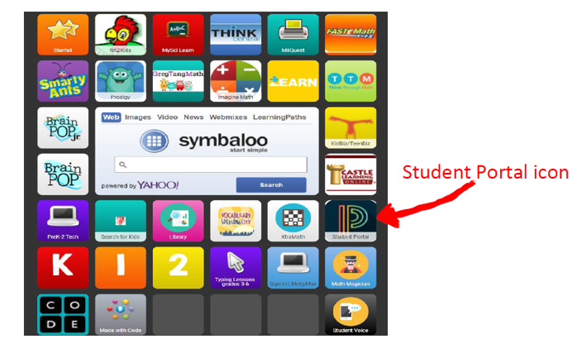

1. Step 2 bring students to **the PowerSchool Student and Parent Sign-in page**. The student username is the same username used to log-on to classroom computers (i.e., jsmith). The **password** is the student’s **5 digit** **student**

**number.**

**Username ________________________**

**Password _________________________**

1. Once logged in, click “Pearson Courses” on the bottom left-hand side of the page. This will take students to the **EasyBridge** student portal.

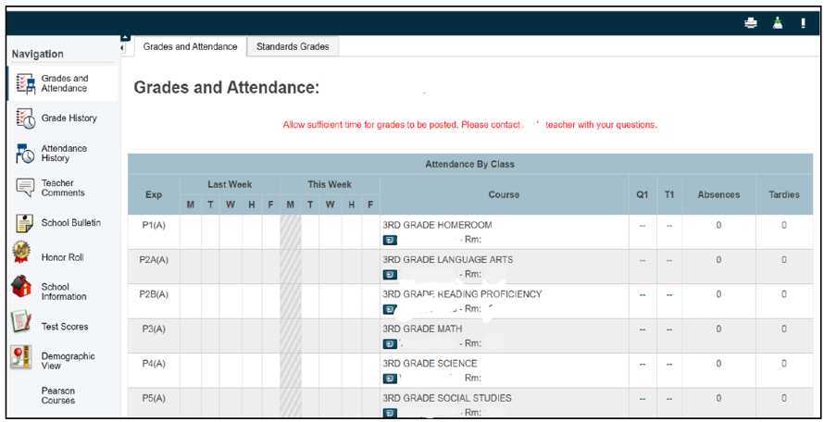



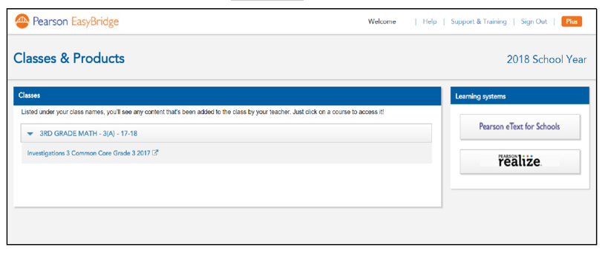

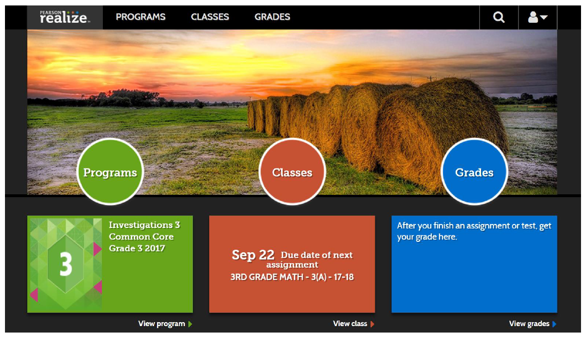

**6. In addition to assignments, students will have full access to their student textbook and a compliment of resources including MWI (Math, Words and Ideas, which have lesson tutorials, notes and review activities), the Game Center and Math Tools. Students can also access games from prior grade levels.**